**DETAIL DESIGN**



**Author: IMAGINEERS**

**Date: 12/02/2017**

**Revision history**

|  |  |  |  |
| --- | --- | --- | --- |
| **Version** | **Date** | **Author** | **Notes** |
| **1.0** | 12/02/2017 | Viet Dnag | Created |
|  |  |  |  |
|  |  |  |  |
|  |  |  |  |

Contents

I. INTRODUCTION 4

II. PROTOTYPE 4

1. SWAPPAL_EXCHANGE SWAP DETAIL 4

2. SWAPPAL_VIEW REVIEW 4

3. SWAPPAL_WRITE REVIEW 6

4. SWAPPAL_STAFF ADDS SKILL 6

5. SWAPPAL_STAFF EDITS SKILL 8

6. SWAPPAL_STAFF ADDS CATEGORY 8

7. SWAPPAL_STAFF EDITS CATEGORY 9

8. SWAPPAL_STAFF VIEWS LIST SKILL 9

9. SWAPPAL_STAFF VIEWS LIST CATEGORIES 10

# INTRODUCTION

This document is created to show the design GUI or sketches of the Swappal website. This document is create for

* Scrum Team
* Product Owner

# PROTOTYPE

## SWAPPAL_EXCHANGE SWAP DETAIL

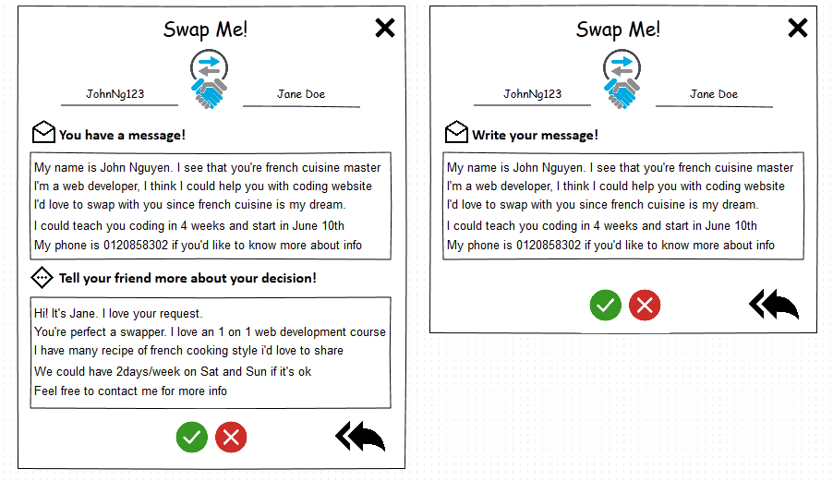

## SWAPPAL_VIEW REVIEW

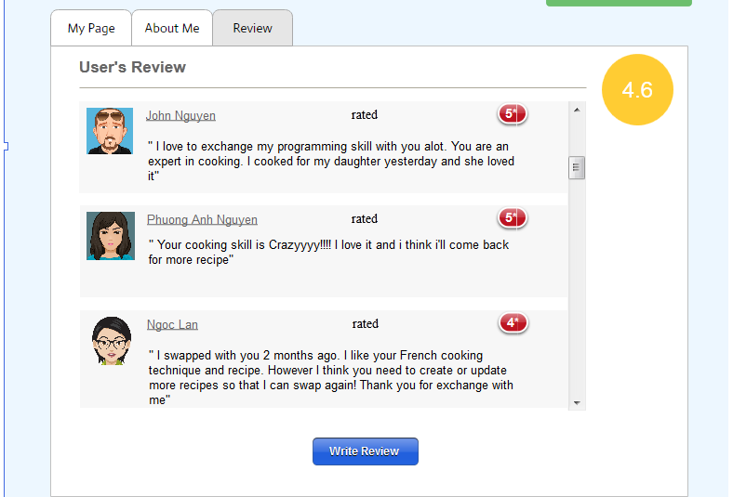

## SWAPPAL_WRITE REVIEW

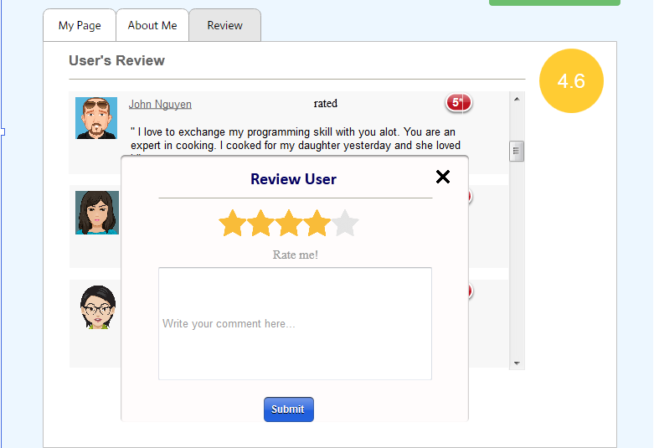

## SWAPPAL_STAFF ADDS SKILL

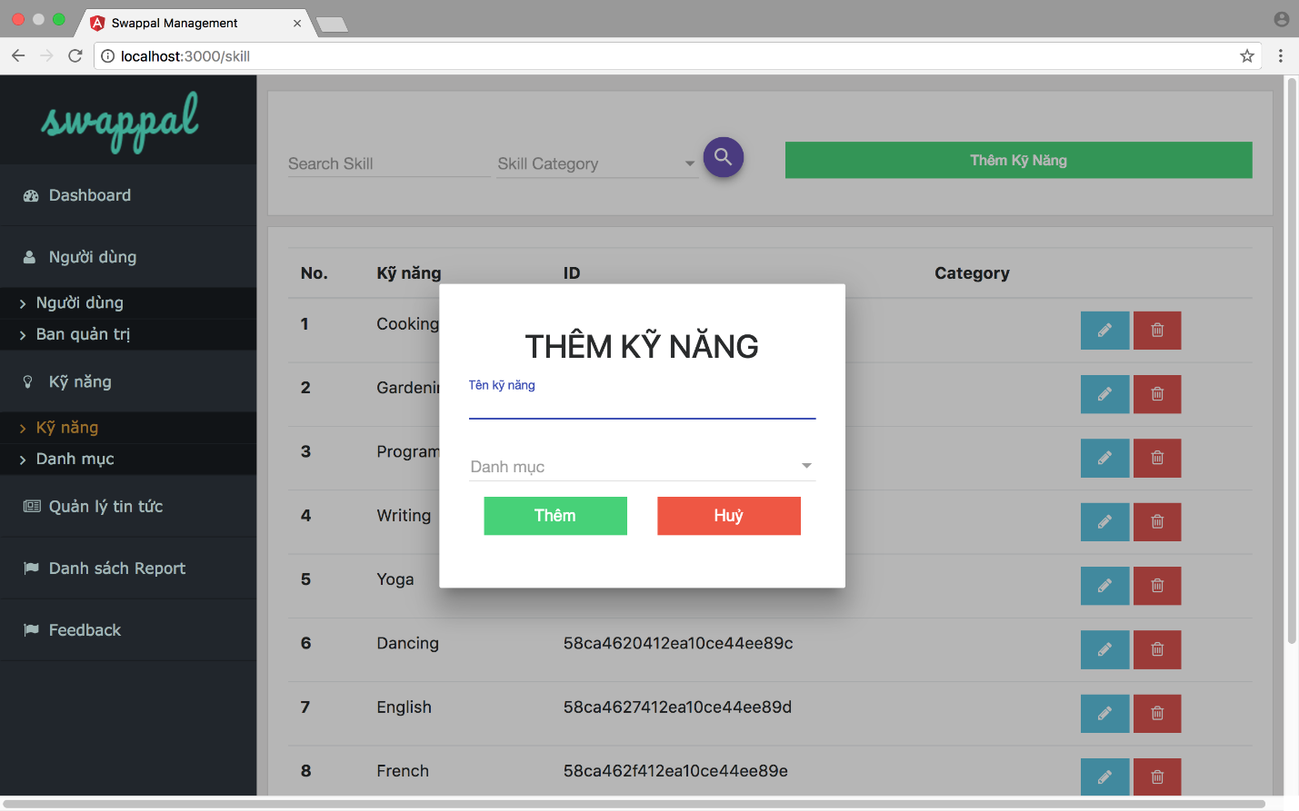

## SWAPPAL_STAFF EDITS SKILL

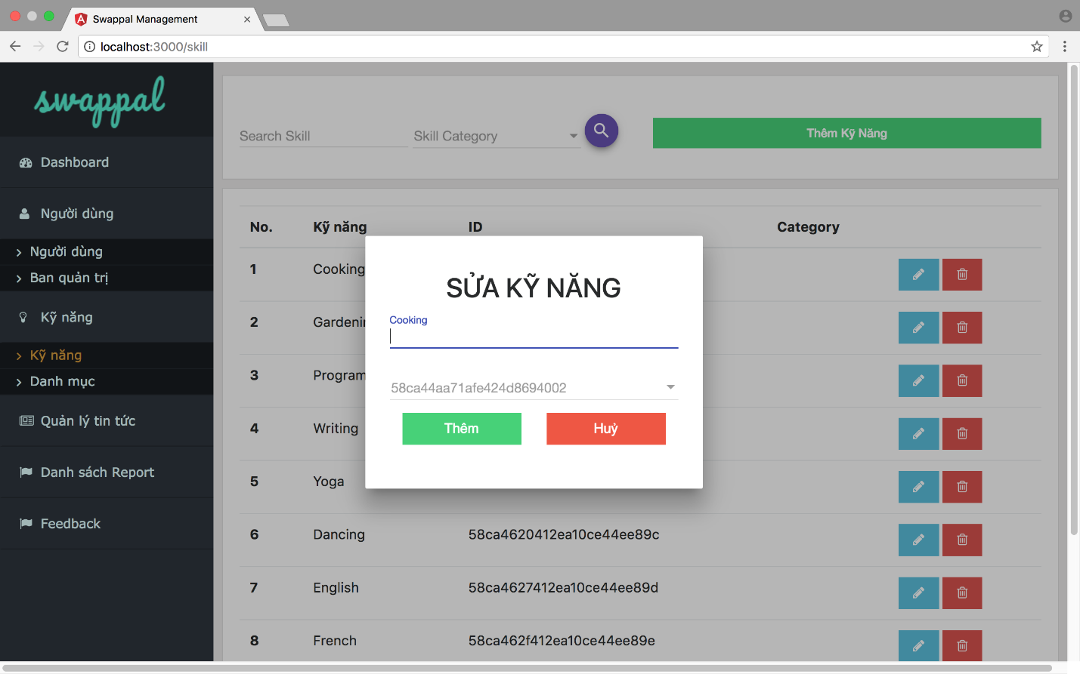

## SWAPPAL_STAFF ADDS CATEGORY

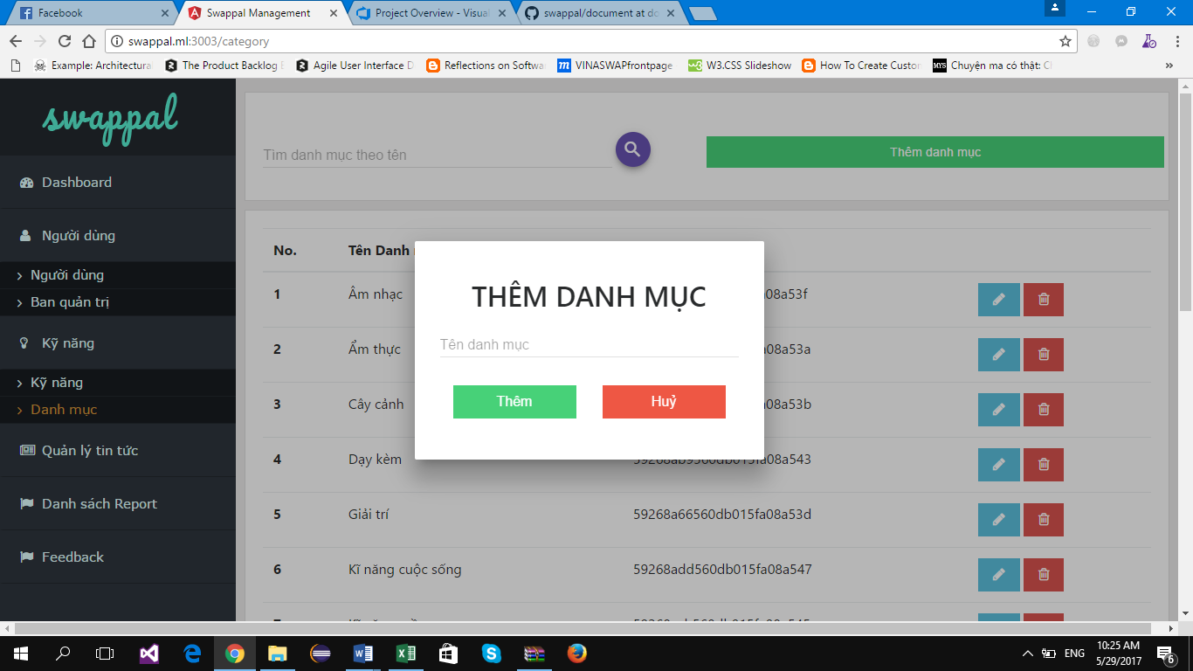

## SWAPPAL_STAFF EDITS CATEGORY

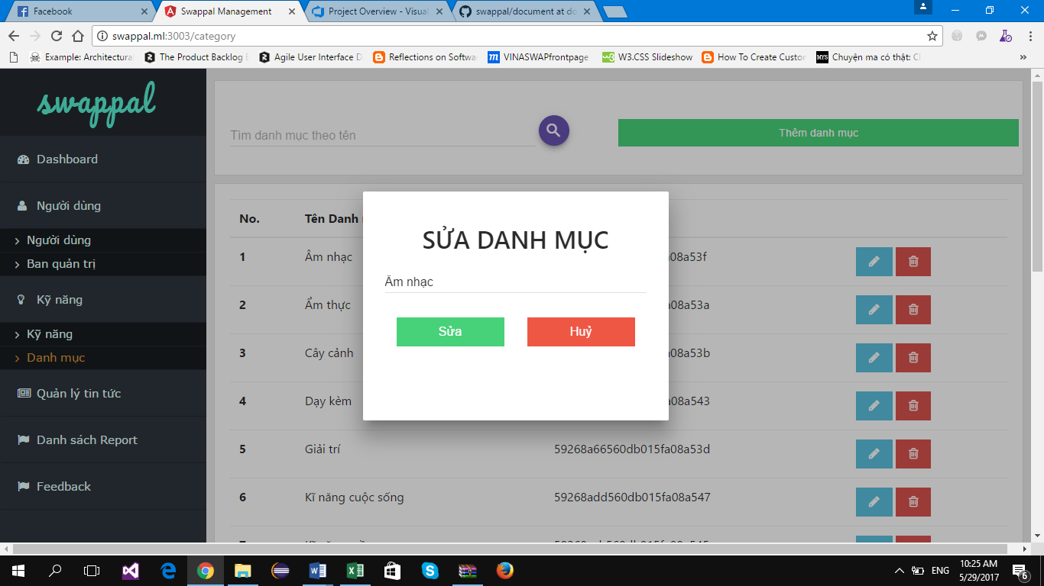

## SWAPPAL_STAFF VIEWS LIST SKILL

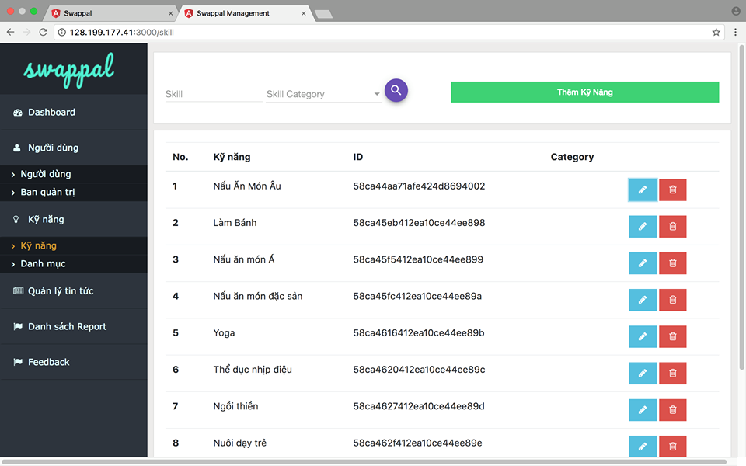

## SWAPPAL_STAFF VIEWS LIST CATEGORIES

